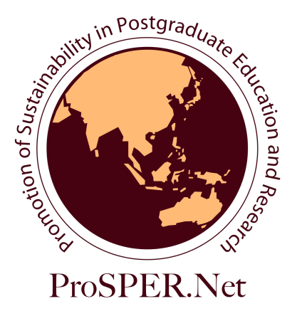


2012 ProSPER.Net Young Researchers’ School
‘Building a Resilient Society in Asia’
Universitas Gadjah Mada, Yogyakarta
17 to 28 September, 2012

Scholarship Application

Applications: Applications are open for PhD students from ProSPER.Net member universities to apply for scholarships to participate in an interdisciplinary intensive Young Researchers’ School on ‘Building a Resilient Society in Asia’.
Scholarship Value: The scholarships cover all costs of Young Researchers’ School tuition, return economy class travel, accommodation and most meals, except for travel insurance, which shall be the participant’s responsibility.
Resource Persons: The Seminar will be taught by leading sustainability experts from ProSPER.Net member universities across the Asia-Pacific region and internationally.
Aims: Participants in the Young Researchers’ School will:
- Develop advanced knowledge and skills in sustainability research and practice, with a special focus on policies and projects involving health and well-being, poverty eradication, social entrepreneurship, urban development and disaster management;
- Develop in-depth research design and planning skills;
- Receive advice on their own thesis and related research proposals;
- Become part of a network of sustainability researchers in the Asia-Pacific region.

Study Theme: In view of Asia’s situation of environmental degradation, occurrence of natural disasters, increasing levels of urbanization, persistence of poverty, all of this impacting on human, social and economic development, the Researchers’ School will provide the participants with the opportunity to explore different dimensions of sustainability issues derived from the current situation and how policies and projects may provide integrative solutions that promote health, well-being, improved levels of income, better quality of life and thus be the foundation for a resilient society. Fieldtrips have been chosen to correspond to specific community development projects being undertaken by Universitas Gadjah Mada, focusing on how research can be practically applied and promote sustainable livelihoods. Along with a series of lectures by resource persons, participants will be introduced to sustainability challenges faced by local communities and the innovative approaches that can be used to address them. Based on these lessons, students will then develop ideas on how to look at problems from their own perspectives and possibly find integrative ways and approaches to promote sustainable solutions.
Other themes in the 2012 school include:
- Life after PhD panel, to help participants realize the potential of their PhD course
- Research communication activities (3-minute thesis exercise, Our World 2.0 workshop)
As well as a focus on the scientific and social scientific content of these sustainability issues, the Young Researchers’ School will engage students in the joint investigation of sustainability issues and also develop the important research skills needed for interdisciplinary problem-based research.
Workshops at the Young Researchers’ School will also focus on research skills and strategies for effective research design and planning, with a focus on student research plan presentations.

Selection Criteria: Participants will be selected on the basis of written application according to the following criteria:
- Currently enrolled in a PhD programme in a ProSPER.Net member university.
- Completion of all coursework and in the thesis stage of their studies to a high level.
- High level of understanding of written and spoken English language.
- An advanced understanding of sustainability and its relevance to their own research.
- Demonstrated ability to work in a team environment and contribute to community service activities.

2012 ProSPER.Net Young Researchers’ School
‘Building a Resilient Society in Asia’
Scholarship Application Form
Family name
Other names
Date of Birth |  |  |  |  | Gender
Email
University
Department
University ProSPER.Net Representative
Email |  |  | Telephone
Yes/No | Currently enrolled |  | University Certification  I certify that the information provided by the applicant is true.  Signature of University ProSPER.Net Representative  Date
Yes/No | All coursework completed
 | Grade Point Average (if applicable)
Yes/No | High level of understanding of written and spoken English language
How does your PhD research relate and contribute to the theme of the school? (maximum 500 words)

Demonstrated ability to work in a team environment and experience in community development/service activities (maximum 500 words)

What is your vision for a resilient society? (maximum 500 words)

Research publications and/or presentations (conferences and dissertation defence etc)
Certification
I certify that the answers to the above questions are true.
Signature |  |  |  | Date

Forms should be completed and emailed as an attachment to yrs@ias.unu.edu by 20 June 2012.

