Guidelines for Final Version of Dissertation Topic
(Graduate)

Tongji University

Guidelines for Final Version of Dissertation Topic
(Graduate)

Foreword
- QuickStart
  - Preparation
  - Parameter
  - Login
- Upload the Final Version of Dissertation Topic
  - Upload
Foreword

Outline
This document aims to provide instructions for students on upload the final version of dissertation topic in Teaching Information System of Tongji University (http://1.tongji.edu.cn)

Target Audience
This document mainly applies to the personnel below:
- Technical Support Engineers
- Students

Recast Record
Recast record includes illustration on every update of document.
The latest version includes all updated contents of former versions.
Version 01 (2020-12-31): First Publication.

QuickStart

  - Preparation
To ensure the operation of Teaching Information System of Tongji University, please prepare your operating environment with reference to this section.

Table 1-1 Operating Environment
Resource | Requirement
Browser | Functional versions of browsers:  - Google Chrome 65 and above  - IE 11  Google Chrome Browser is recommended.

  - Parameter
In this instructive document, the parameters set in the examples are for the purpose of better demonstration. Please configure settings according to your actual situation. Some parameters are not given, and they need to be configured according to the actual situation. This document does not provide specific values of any parameter.

  - Login

Background
Students can proceed their final dissertation topic upload in Teaching Information System of Tongji University.

Procedure
Step 1: Open a browser.
Step 2: Enter “http://1.tongji.edu.cn” or “http://1.tongji.edu.cn/locallogin” in the address bar, and the landing page of Teaching Information System of Tongji University will display, as picture 1-1 and picture 1-2 show below.

Pic 1-1: Landing Page (http://1.tongji.edu.cn/locallogin)
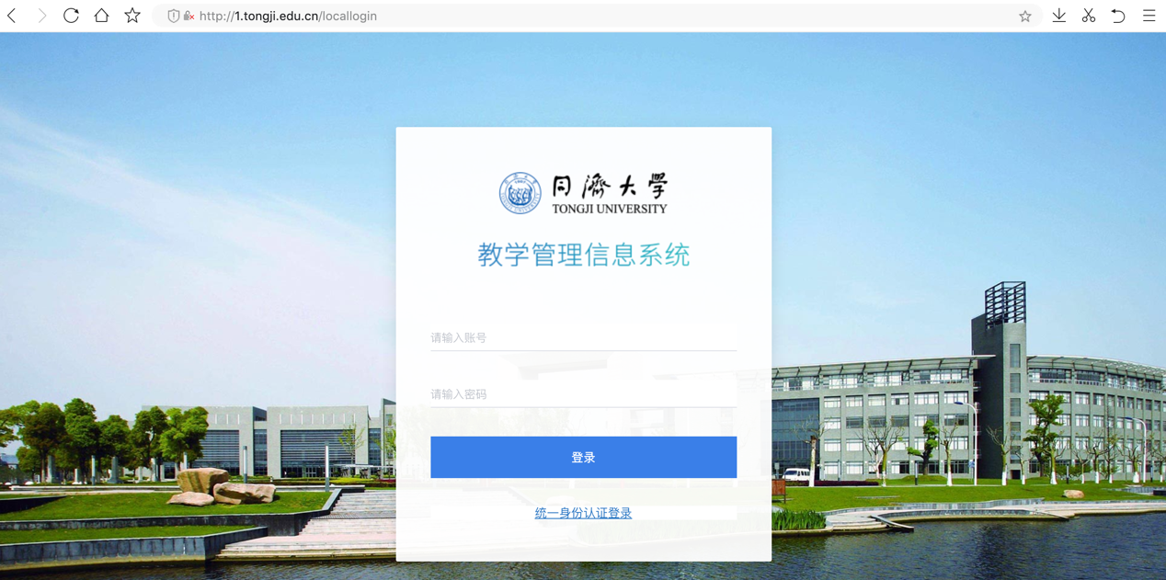

Pic 1-2: Landing Page (http://1.tongji.edu.cn)
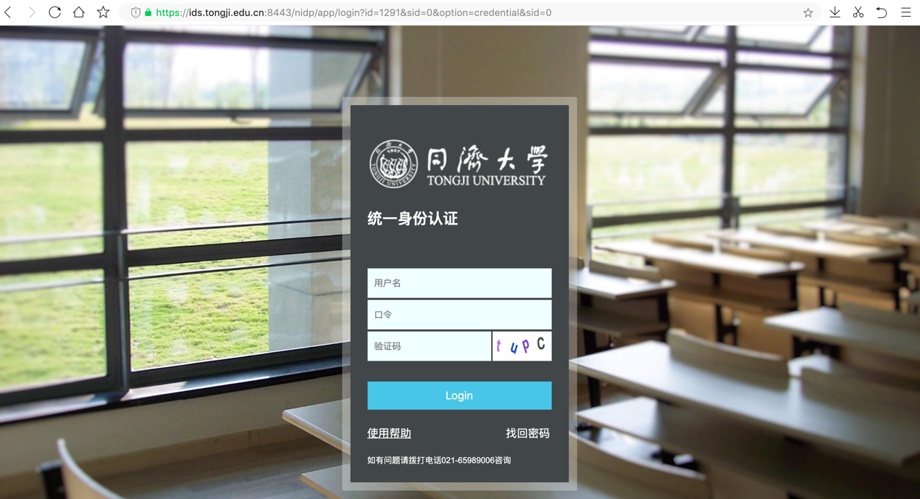

Step 3: Input “User Name”(用户名) and “Password”(密码)
Step 4: Click “Login” (登陆) and enter “Dissertation Topic Selection” (论文选题)> “Upload Final Version of Dissertation Topic” (论文选题最终版本上传) menu.
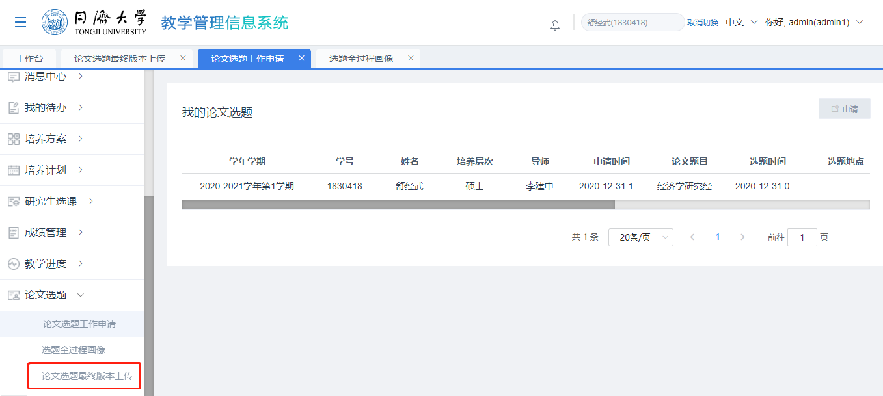
Note
- “Upload Final Version of Dissertation Topic” menu is only available when you are given the permission. If the menu is not available, please contact faculty or administrators for authorization, after which you can log out and log back in to check the menu.

----END

Upload the Final Version of Dissertation Topic
2.1 Upload

Background
Students can revise their dissertation titles and upload the final version of dissertation topic.

Procedure

Step 1: Make sure your application for dissertation topic selection has been approved.
After entering the “Upload the Final Version of Dissertation Topic” page, you need to make sure that your application for dissertation topic selection has been approved, otherwise you cannot upload the final version of dissertation topic or revise your dissertation title, where the system would inform you the failure in upload the final version of dissertation topic.
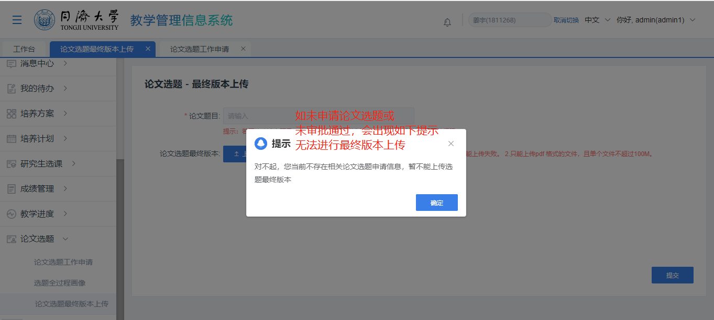

Step 2: Ask your supervisor or administrator for authorization.
After ensuring your application for dissertation topic selection has been approved, you need authorization to enter the “Upload the Final Version of Dissertation Topic” page. Otherwise, the system would only allow you to read the information on the page rather than revise it.

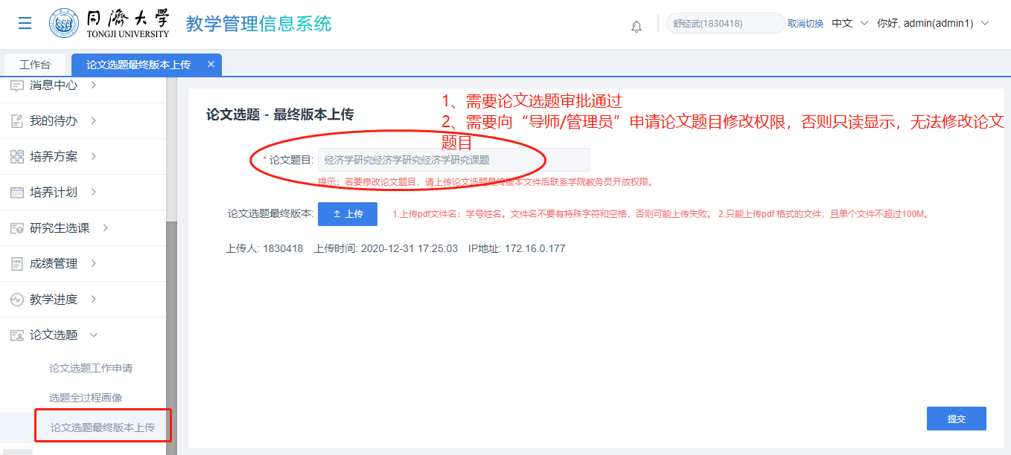

Step 3: Upload your final version of dissertation topic.
Having been authorized by your supervisor/administrator, you need to refresh the page or log out and log back in. When the page becomes editable, you can revise your dissertation topic and upload the final version of dissertation topic.
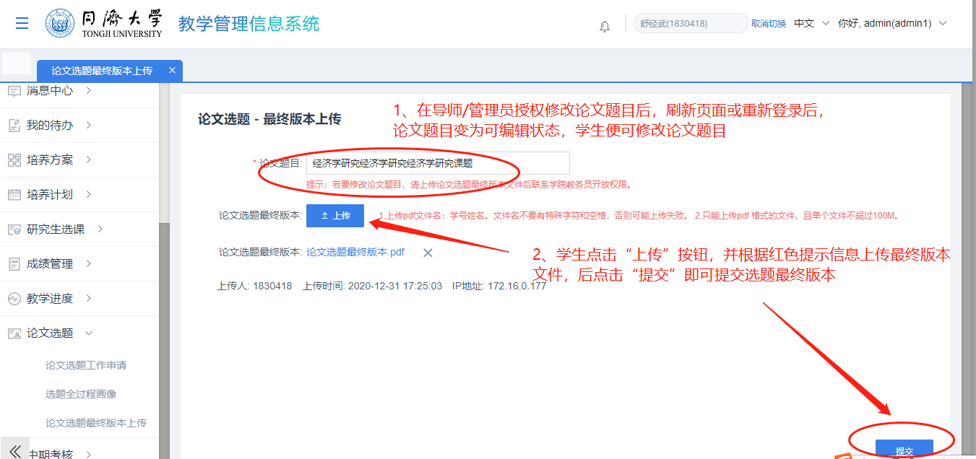

Step 4: Check your revised dissertation title.
After revising your dissertation title, you can enter the “Application for Dissertation Topic Selection” menu and check your revised dissertation title to ensure the modification is successful.
