Guidelines for formulating personal training scheme (Graduate)

Open the page: http://1.tongji.edu.cn, use your student number as ID to log in.

- Click “My Training Scheme” (我的培养计划) in the menu.
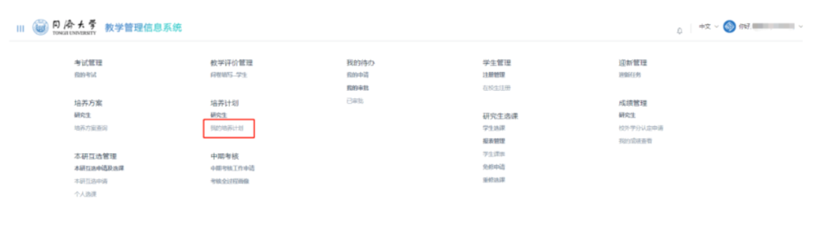
Or you can also click “Personal Scheme” (个人计划) on the homepage.
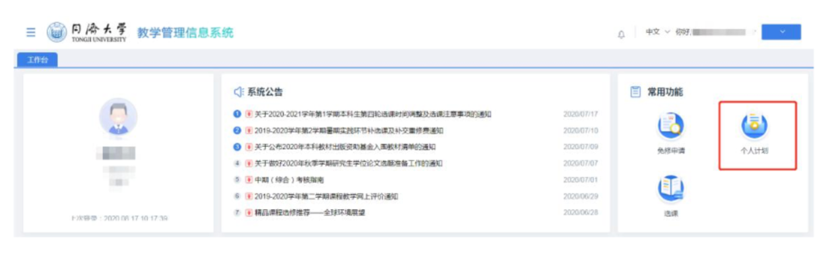

- Click “Formulate a Scheme” (制定计划)
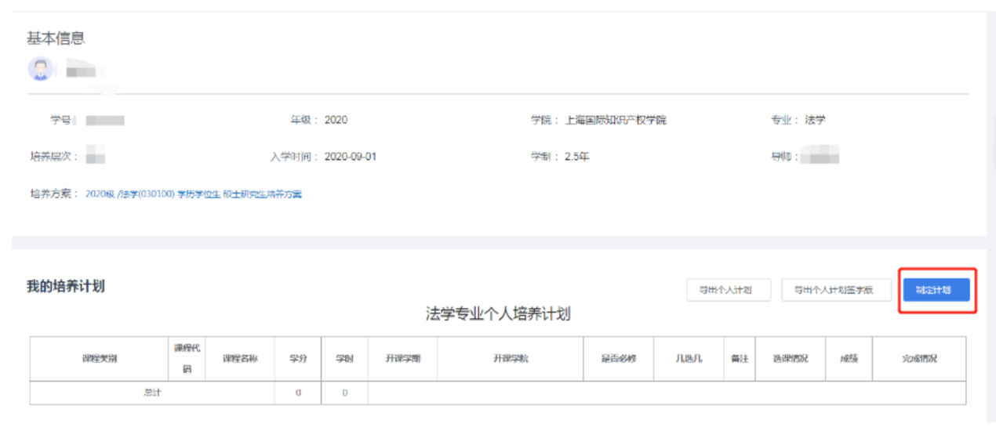

- Formulate your training Scheme under the guidance of your supervisor.
(1) Register Common Course (选择公共学位课)
* Foreign students and students from Hong Kong, Macau, and Taiwan are required to take the course: A General View of China (中国概况).
* The first foreign language shall be identical to that of your entrance examination and application.
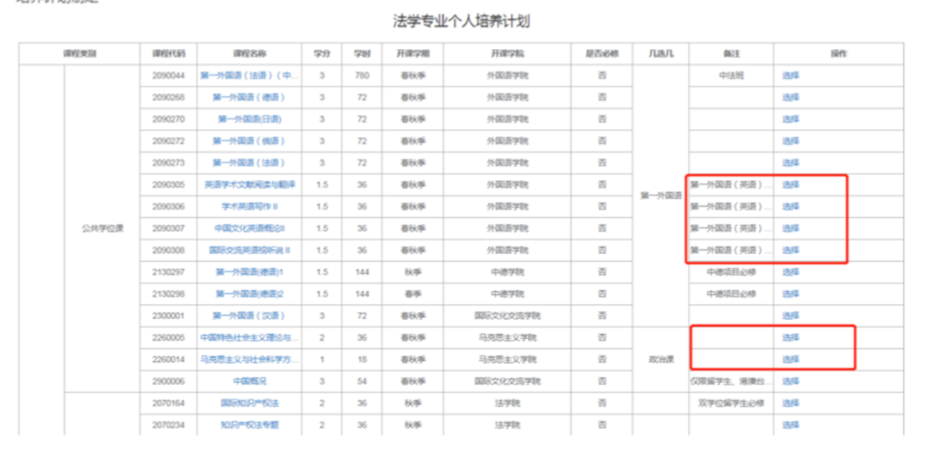

(2) Register Core Course and Elective Course (选择专业学位课和非学位课).
Read the course note carefully, and choose the courses that fit your major or research. Do not choose the wrong courses or forget the right ones.
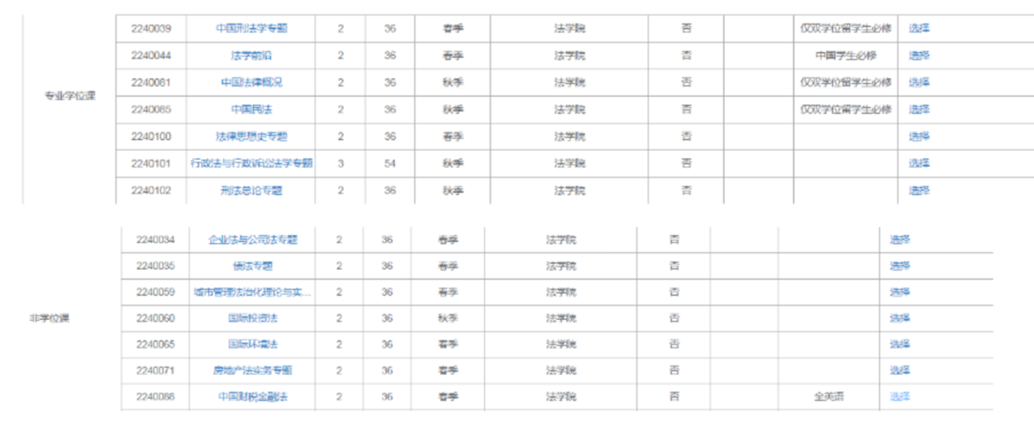
* Change the category of the course. (修改课程类型)
If there is no special demands of your program, you can change the category of a course from “core course” into “elective course” by clicking “Change the Category” (修改课程类型)
The category of core courses assigned by your research group cannot be change.
The category of elective courses cannot be changed.
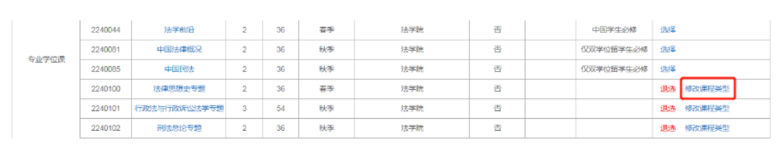
* To cancel a course, click “Cancel” (退选)
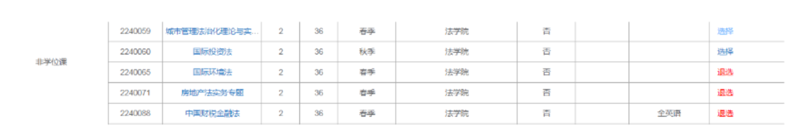

(3) Register Compulsories (选择必修环节)

(4) Register Complementary Course (选择补修课)
Most majors require no complementary courses. Only a few programs include complementary courses. Choose complementary courses according to the requirement of your school and supervisor. Complementary courses are noncredit, but the training scheme will not be finished unless you take the complementary courses required.

(5) Register Interdisciplinary Courses (选择跨院系课程)
Click “Interdisciplinary Courses” (跨院系课程), input course name or course number to search interdisciplinary courses, check the box and click “OK” (确定) to choose the course you need.
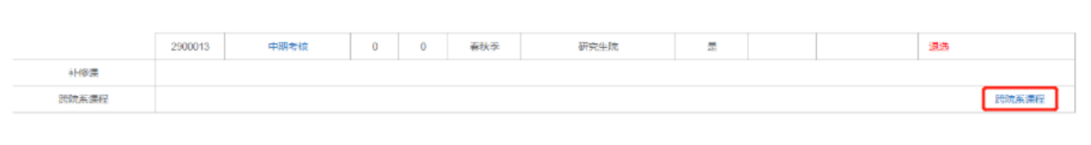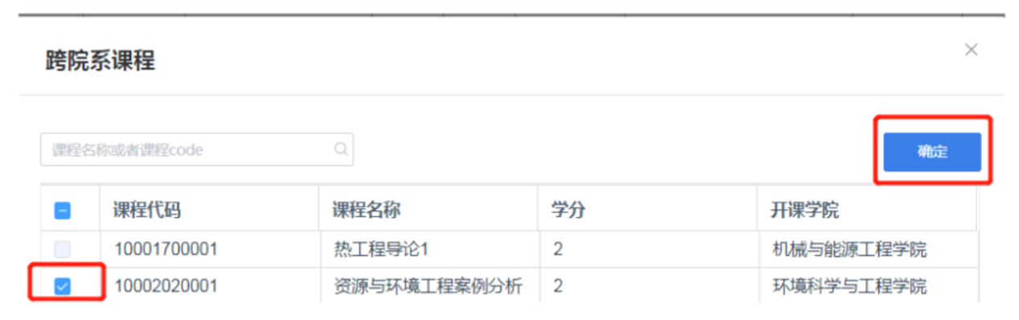
* Switch interdisciplinary courses.
To ensure you do not forget to choose interdisciplinary courses, the system will not allow the chart to be empty. If you need to change course A to course B, please add both course A and course B in the chart and remove course A later.

Note: Take interdisciplinary courses as your training program requires.
To check whether a certain interdisciplinary course is available this semester, you can click the “Training Program Inquiry”(培养方案查询) menu, enter the number of the year and you would have training programs of all majors. Click the program, find the course you need, choose “Curriculum Inquiry”(开课情况查询), and you would see if it’s available this semester.

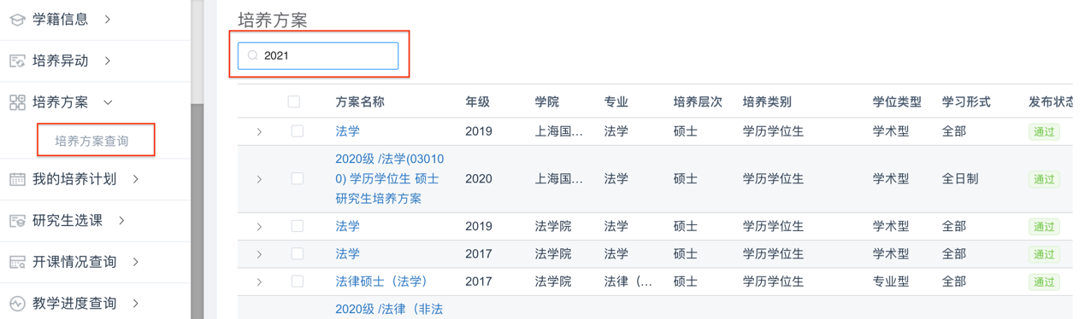

(6) Save and Submit
Common courses, core courses, elective courses, interdisciplinary courses, compulsories and total credits should meet the requirement of your training program. interdisciplinary courses belong to elective courses. You can save the personal training scheme as long as you have made any modification. Click “Submit” (提交) after you having ensured that the personal training scheme is settled.
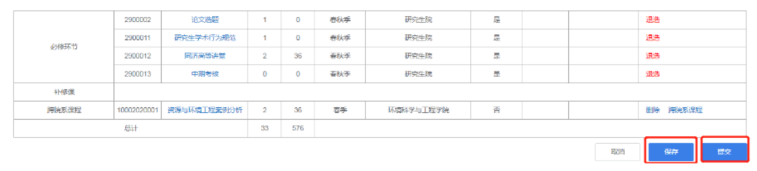
If the personal training scheme does not meet the requirement of your training program, you should modify it following the instructions.
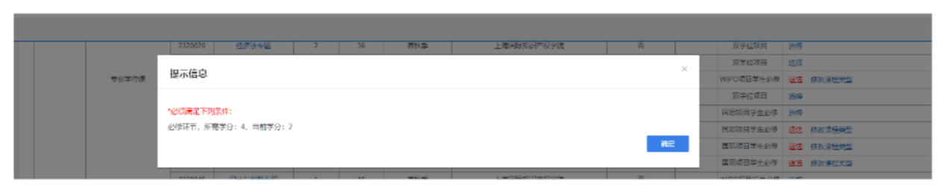
After having submitted your personal training scheme successfully, you can see a new chart of “Progress of training” (培养计划完成情况表)
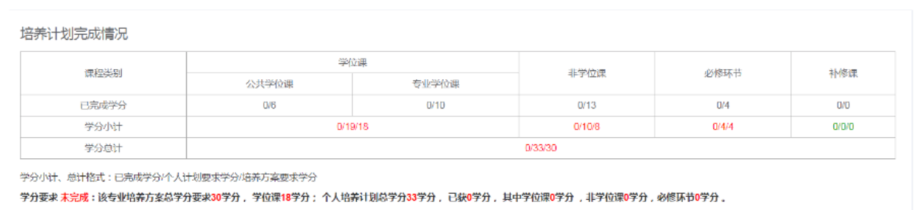

Click “Export”(导出个人计划签字版) to export your personal training scheme in the form of PDF.
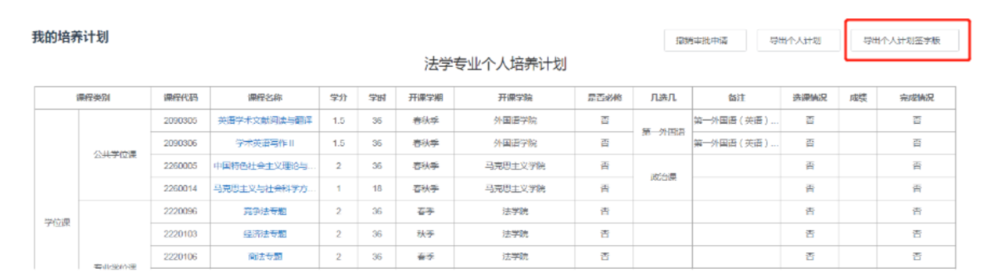

You can withdraw your personal training scheme before it’s assessed by your supervisor; just click “Withdraw” (撤销审批申请) in “My Personal Training Scheme” (我的个人计划) menu.
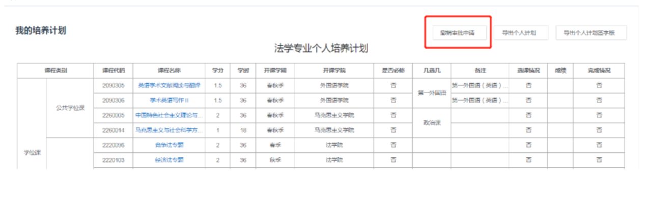

(7) Personal training scheme of graduate students shall be assessed by their supervisors within two weeks after registration.

