学生登录同济大学教学管理信息系统【Students log into the teaching Management information system of Tongji University】

背景信息【background information】

学生可通过访问同济大学教学管理信息系统网址<http://1.tongji.edu.cn>进行论文选题业务申请办理。【Students can visit the website of Tongji University teaching Management Information System (URL: http://1.tongji.edu.cn) to apply for thesis topic selection. 】

操作步骤【operating steps】

打开浏览器。【Open your browser】

在地址栏中输入<http://1.tongji.edu.cn>或<http://1.tongji.edu.cn/locallogin>（生产环境）

系统显示教学管理信息系统登录页面，如图1-1所示。【Enter <http://1.tongi.edu.cn> or <http://1.tongji.edu.c/locallogin>，the teaching management information system login page is displayed, as shown in Figure 1-1.】

系统登录页面

本地用户登录界面：【Login page Local user login page:】

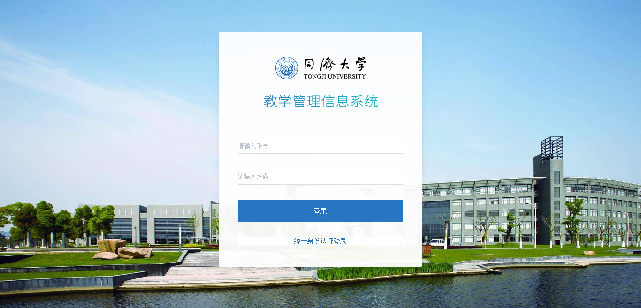

系统登录页面

统一身份认证登录：【Unified identity authentication login】

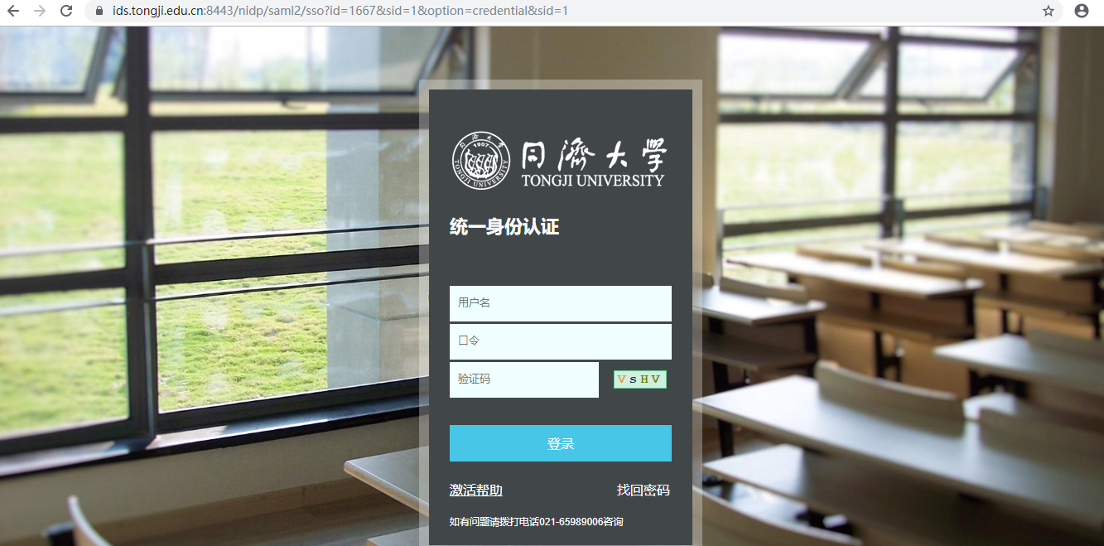

输入“用户名”和“密码”。【Enter the user name and password. 】

点击“登录”，正常登录，登录后进入“论文选题”菜单。【Click "Login" to log in normally and then enter the menu of "Thesis Selection".】

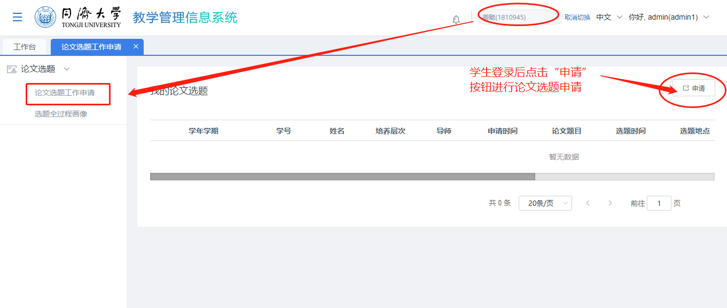

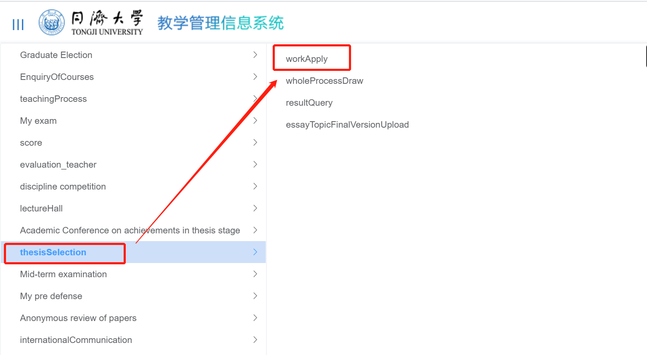

image013

学生需要老师配置权限后才可看到“论文选题”菜单，如未看到“论文选题工作申请”菜单，请联系老师或管理员为其授权后再重新登录查看。

需要在申请选题时间范围内才能申请论文选题。

【Instructions：Students can see the menu of "Thesis Topic selection" only after the teacher has configured the permission. If you do not see the menu of "Thesis Topic Selection Work Application", please contact the teacher or administrator to authorize it and log in again. You can only apply for thesis topic selection within the application time range.】

**论文选题申请**

2.1 选题申请【Application for Topic selection】

背景信息【Background information】

在选题申请权限开放后，学生在“论文选题工作申请”菜单中查看并申请论文选题。学生需在规定时间内提交论文选题申请，若未到开放时间，点击则无法申请论文选题。【After the application permission is opened, students can view and apply for a thesis topic in the Application menu. Students are required to submit the application for topic selection within the specified time. If it's not the open time, click the application will not be able to choose topic selection.】

学生申请时，可根据实际情况选择申请类别（选题和缓选题,两者只能二选一）。【When applying, students can choose the type of application according to the actual situation (between selected topic or delayed selection, the two can only choose one).】

操作步骤【operating steps】

2.1.1正常选题申请【normal application for topic selection】

学生登录同济考务管理系统，进入“论文选题->论文选题工作申请”菜单；【Students log in the education management system of Tongji University and enter the "Thesis Selection-> menu of Work Apply】

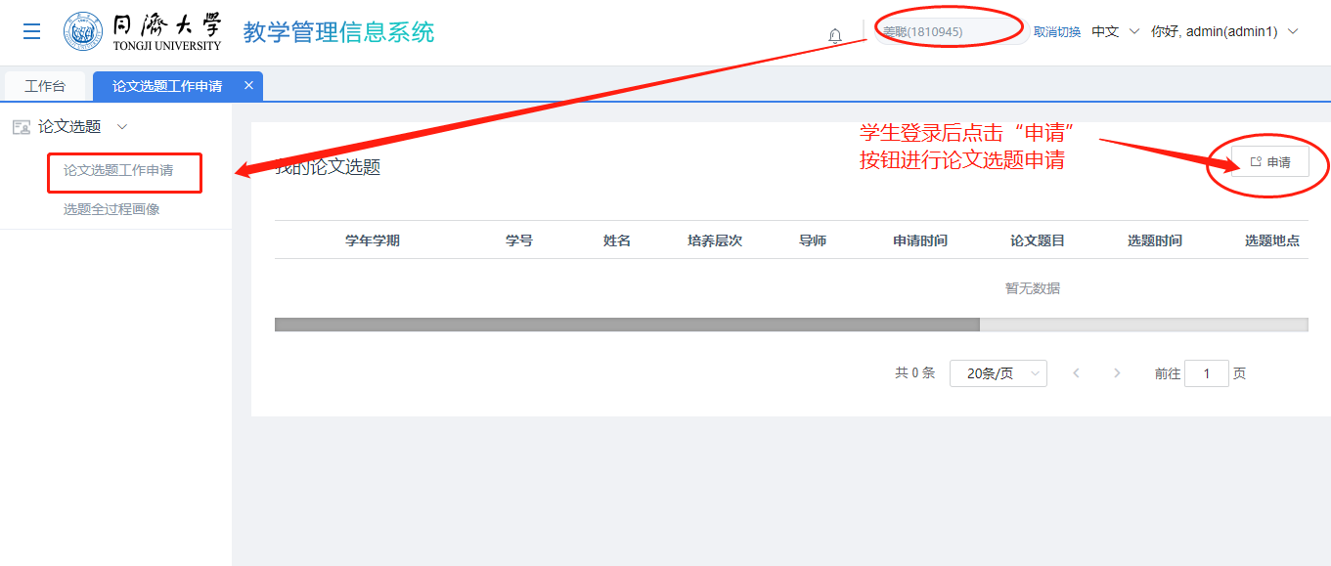

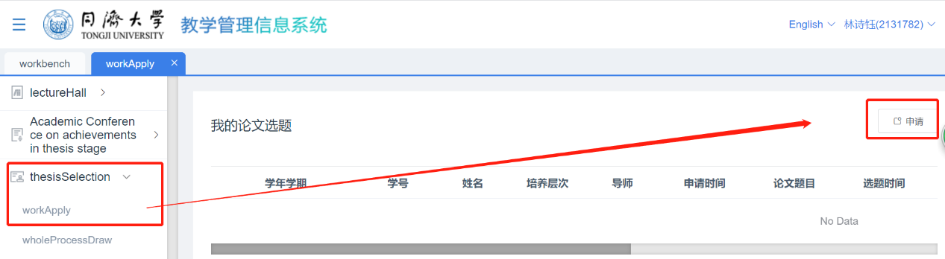

点击“申请”按钮，进入“申请”选题界面，选择“选题”或者“缓选题”（正常申请选择“正常选题”）；【Click “apply”, then choose normal selection(the first line) or delayed selection(the second line)】

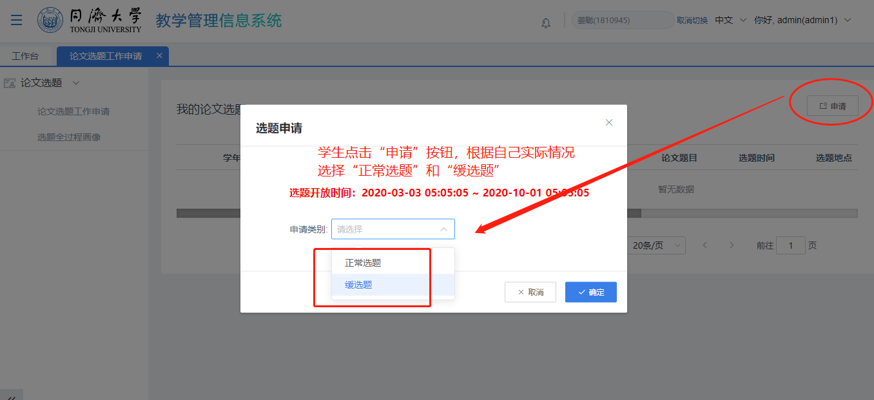

选择“正常选题”，点击“确定”进入学生基本信息界面；【choose “normal selection”, then click “confirm” to enter the student basic information interface】

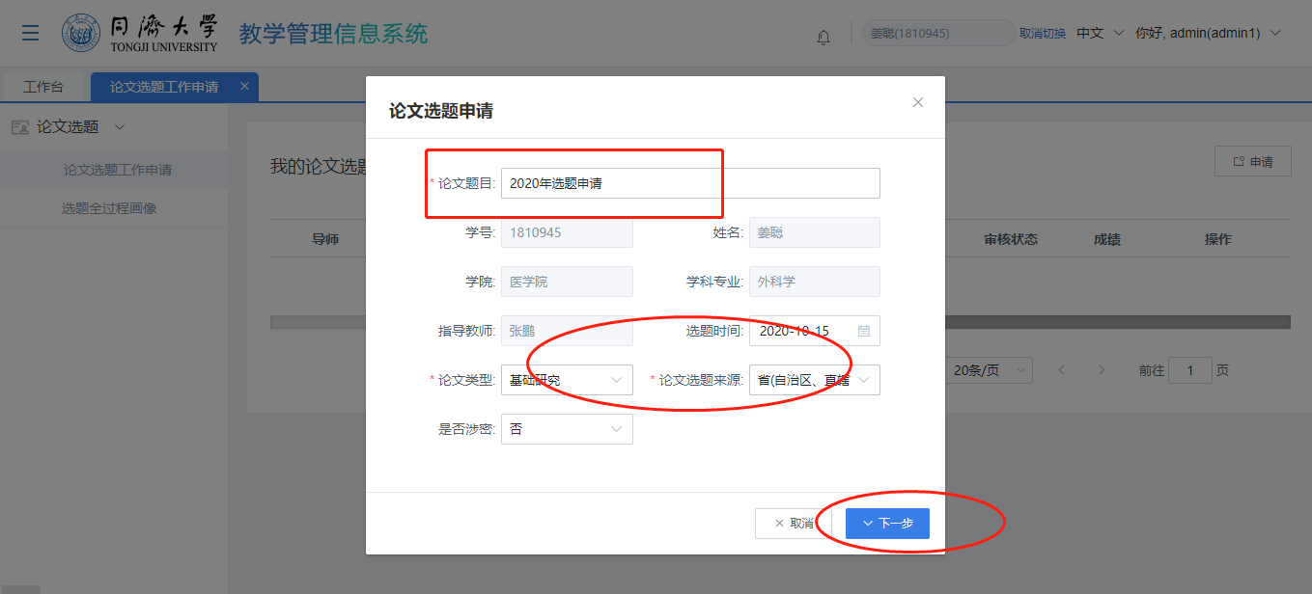

再点击“下一步”，进入选题内容上传PDF文件界面，学生可选择符合自己培养类别的已填写完成的《研究生学位论文选题报告及工作计划》的PDF进行上传；【Click "Next Step" to enter the interface for uploading the selected topic.

Students can select the completed PDF of <Selected Topic Report and Work Plan of Graduate Dissertation> that fits your academic category to upload】

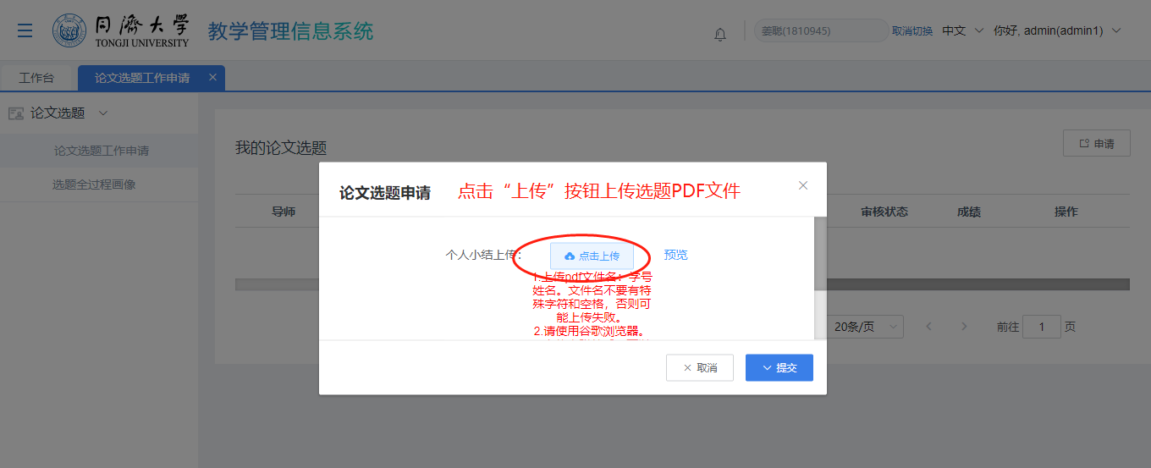

image013

只能上传1个PDF文件。同时注意红色上传提示信息：1）上传pdf文件名：学号姓名。文件名不要有特殊字符和空格，否则可能上传失败；2）请使用谷歌浏览器；3）上传完附件后，可以线上预览，如果无法预览说明上传失败，可以撤回重新上传。

【Instruction

You can upload only one PDF file. And please notice the red upload prompt: 1) Upload PDF file name: student ID and name. Do not include special characters or Spaces in the file name; otherwise, the upload may fail. 2) Please use Google Chrome; 3) After uploading the attachment, you can preview the attachment online. If you cannot preview the attachment, it indicates that the upload failed and you can withdraw the attachment and upload it again.】

上传PDF文件后，点击“提交”按钮，可提交选题申请，同时在选题工作申请列表中生成申请电子流，进入导师审核环节，学生可根据“审核状态”进行跟踪选题申请电子流审批状态。【After uploading the PDF file, click the "Submit" button to submit the application for topic selection. At the same time, the electronic flow of application will be generated in the application list for topic selection to enter the tutor's review process. Students can track the approval status of electronic flow of topic selection application according to the "review status".】

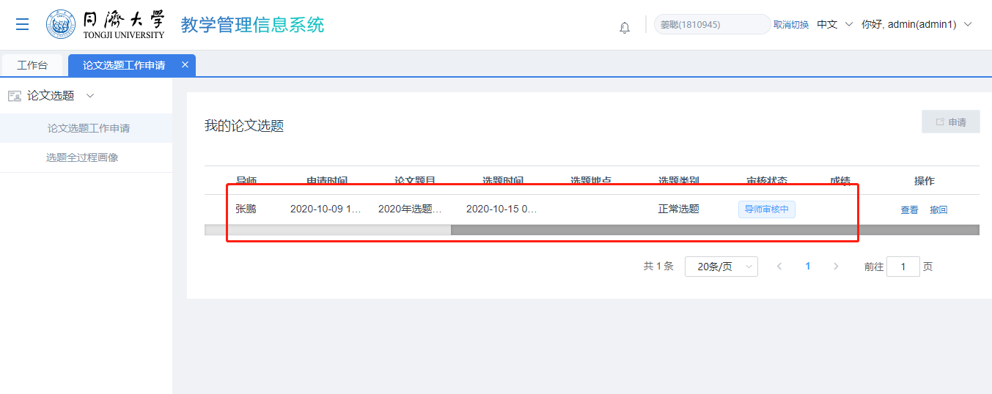

学生如果填写错误，在导师申请未结束前，还可以点击“撤回”按钮，撤回提交的电子流，进行重新提交选题申请。【If you fill in the wrong information, you can click the "Withdraw" button to withdraw the electronic stream and resubmit the application before the teacher review process ends.】

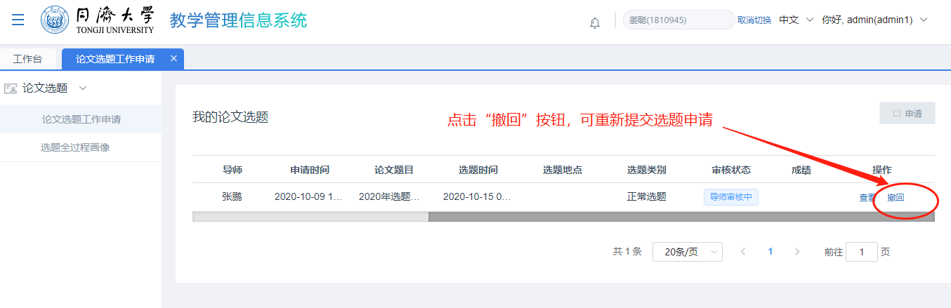

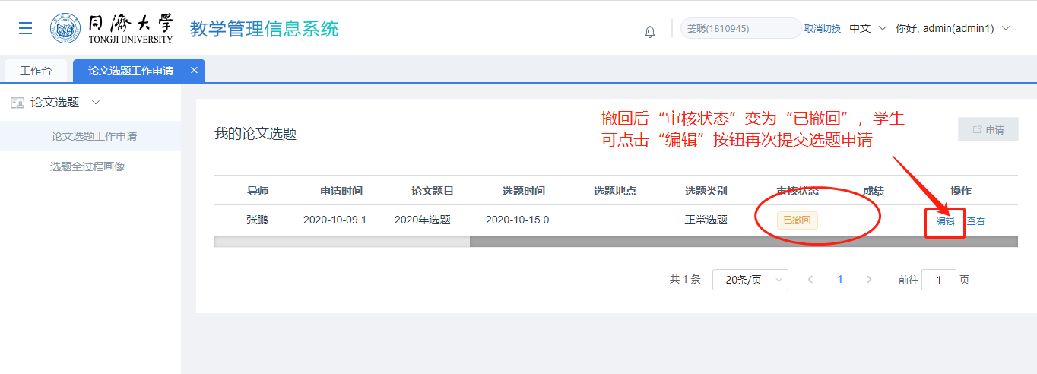

2.1.2 缓选题申请【Application for Delayed Topic Selection】

学生登录同济考务管理系统，进入“论文选题->论文选题工作申请”菜单；【Students log in the education management system of Tongji University and enter the "Thesis Selection-> menu of Work Apply】

学生点击“申请”按钮，进入选题“申请”界面，选择“缓选题”进行缓选题申请；【Click “apply”, then choose delayed selection(the second line)】

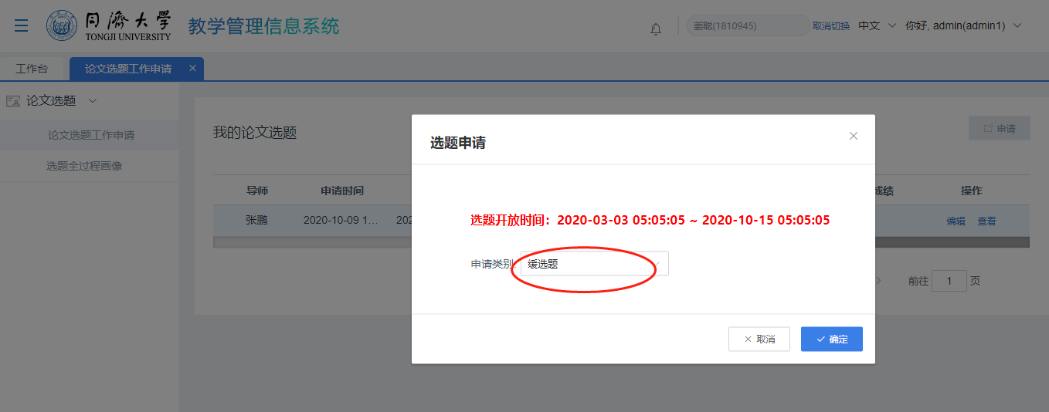

点击“确定”，进入“缓选题”信息填写界面；【choose “delayed selection”, then click “confirm” to enter the page of information about delayed selection】

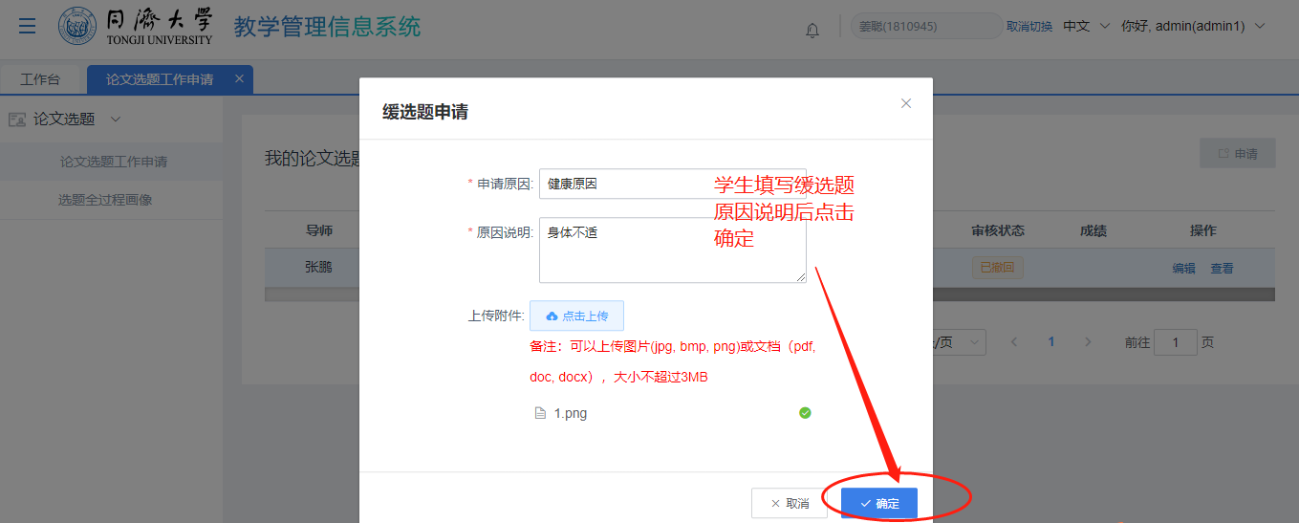

选择申请原因、填写原因说明、如果需要上传附件可以上传附件，然后点击“确定”，提交缓选题成功，进入选题列表可看到缓选题记录；【Select the application reason, fill in the explanation of the reason, upload the attachment if necessary, and click "confirm" to submit the delayed topic selection successfully. Enter the list of topics and you can see the record of the delayed selection.】

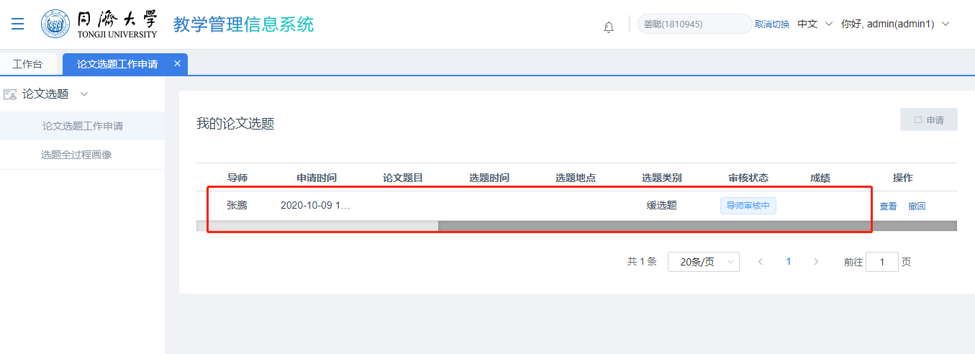

点击“查看”按钮，还可查看缓选题详情信息；【Click "View" button, you can also view the details of delayed topic selection.】

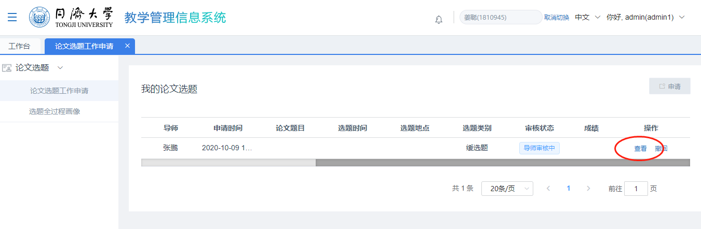

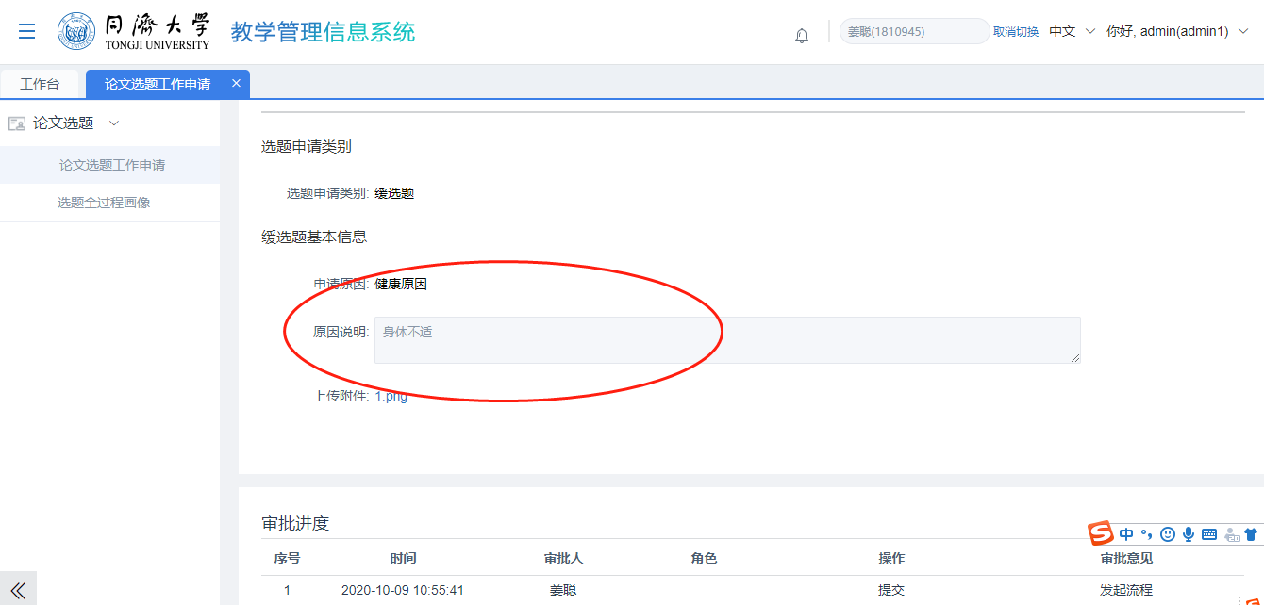

点击“撤回”按钮，可撤回缓选题申请，进行重新编辑提交。【Click "Withdraw" button, you can withdraw the application for delayed topic selection, edit and submit again. 】

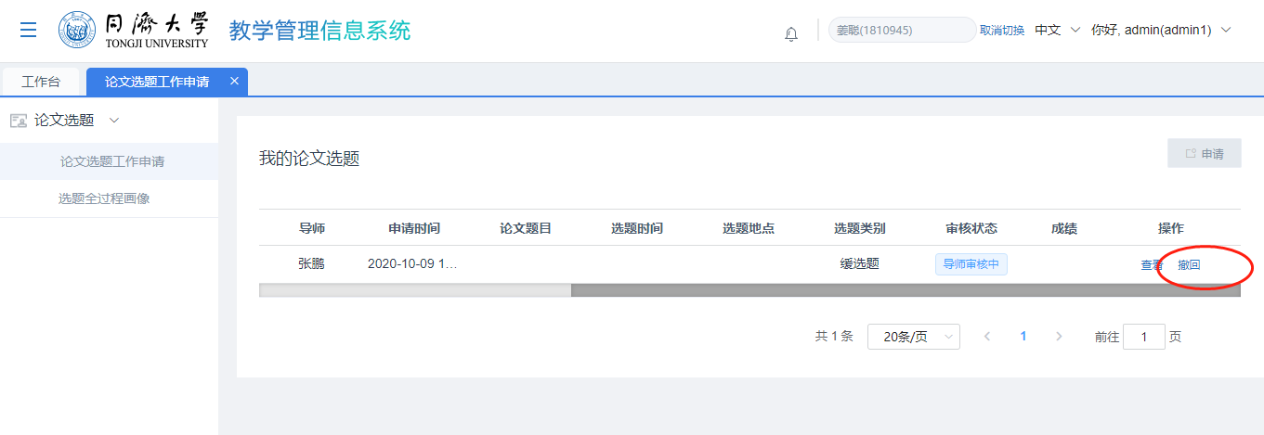

2.1.3 撤回正常选题或缓选题【Withdraw the submitted application】

学生在选题（包括选题和缓选题）未被审批通过前，可点击“撤回”按钮撤回提交的选题（选题或缓选题）申请；【Students can click the "Withdraw" button to withdraw the submitted application before the selected topic (including topic selection and delayed selection) is approved.】

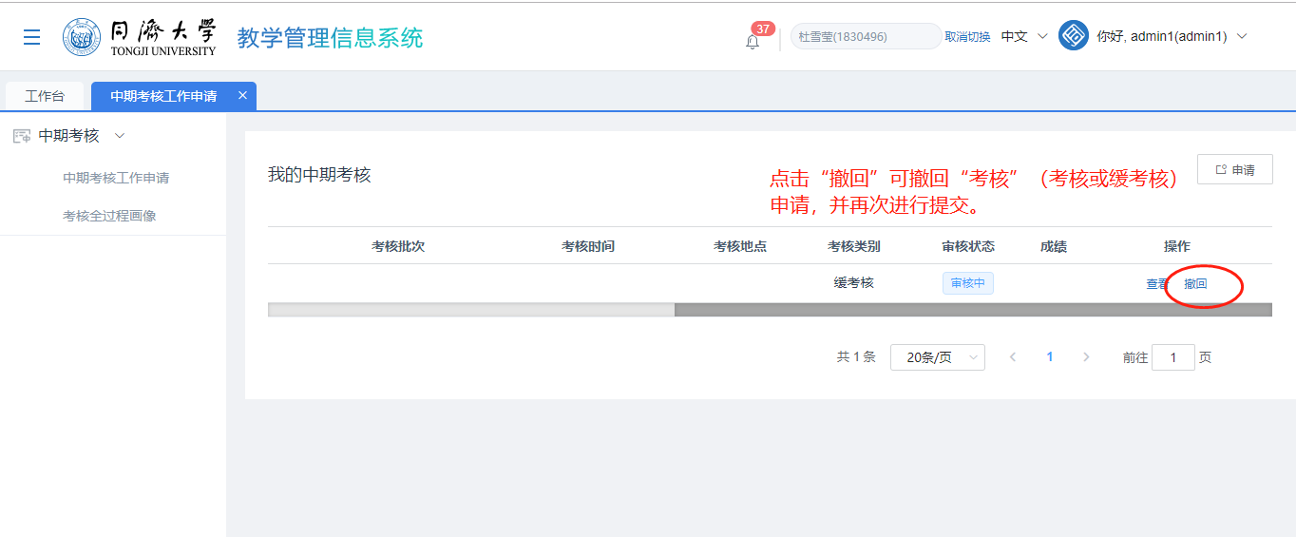

撤回后选题状态变为“已撤回”状态，学生可点击“编辑”或点击“申请”按钮再次提交选题或缓选题。【After the withdrawal, the thesis topic selection status changes to "Withdrawn", students can click "Edit" or click "Apply" button to submit the topic again or postpone the topic.】

