

**Guidelines for Mid-Term Examination (Graduate)**

**Tongji University**

**Guidelines for Mid-Term Examination (Graduate)**

Foreword

1. QuickStart
   1. Preparation
   2. Parameter
   3. Login
2. Apply for Mid-Term Examination
   1. Application
   2. Process Record
   3. Query Result

**Foreword**

**Outline**

This document aims to provide instructions for students on mid-term examination in teaching information system of Tongji University (<http://1.tongji.edu.cn>)

**Target Audience**

This document mainly applies to the personnel below:

* Technical support engineers
* Students

**Recast Record**

Recast record includes illustration on every document update.

The latest version includes all updated contents of former versions.

Version 01 (2020-05-12): First Publication.

**QuickStart**

* 1. **Preparation**

To ensure the operation of Teaching Information System of Tongji University, please prepare your operating environment with reference to this section.

Table 1-1 Operating Environment

|  |  |
| --- | --- |
| Resource | Requirement |
| Browser | Functional versions of browsers:   * Google Chrome 65 and above * IE 11   Google Chrome Browser is recommended. |

* 1. **Parameter**

1. In this instructive document, the parameters set in the examples are for the purpose of better demonstration. Please configure settings according to your actual situation. Some parameters are not given, and they need to be configured according to the actual situation. This document does not provide specific values of any parameter.
   1. **Login**

**Background**

Students can proceed their application for mid-term examination in Teaching Information System of Tongji University.

**Procedure**

**Step 1:** Open a browser.

**Step 2:** Enter “<http://1.tongji.edu.cn>” or “<http://1.tongji.edu.cn/locallogin>” in the address bar, and the landing page of Teaching Information System of Tongji University will display, as picture 1-1 and picture 1-2 show below.

Pic 1-1: Landing Page (<http://1.tongji.edu.cn/locallogin>)

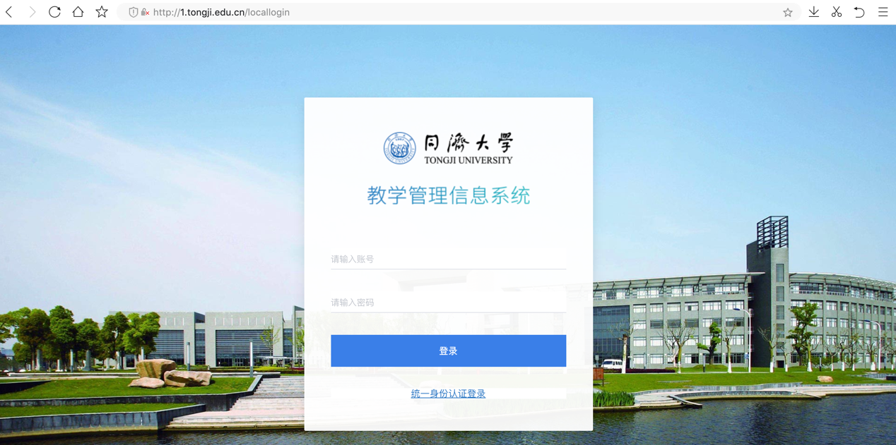

Pic 1-2: Landing Page (<http://1.tongji.edu.cn>)

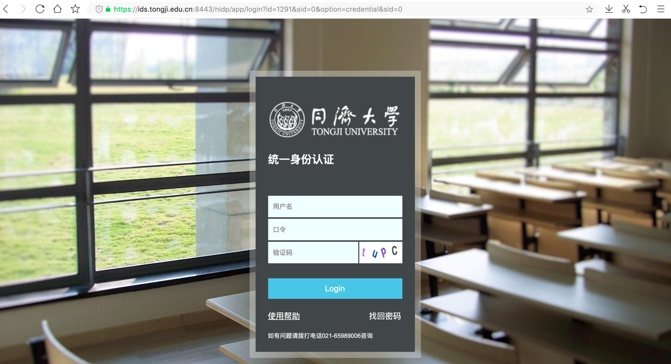

**Step 3:** Input “User Name”(用户名) and “Password”(密码)

**Step 4:** Click “Login” (登陆) and enter “Mid-Term Examination” (中期考核) menu.

文本



Note

* “Mid-Term Examination” menu is only available when you are given the permission. If “Mid-Term Examination” menu is not available, please contact faculty or administrator to authorize, after which you can log out and log back in to check the menu.
* Application for mid-term examination is only available within a given period.

----END

**Apply for Mid-Term Examination**

**2.1 Application**

**Background**

Once authorized, students shall check and apply for mid-term examination in the “Application for Mid-Term Examination” menu (中期考核工作申请) Students are required to submit their application within the given period. The menu only displays within the valid time period.

When applying for mid-term examination, students can choose one kind of application based on their actual situation. (Between Application for Mid-Term Examination and Application for Postponement, students have to choose either one.)

**Procedure**

2.1.1 Normal Application

**Step 1:** Log in Teaching Information System, entering “Mid-Term Examination”(中期考核) > “Application for Mid-Term Examination”(中期考核工作申请)

**Step 2:** Click “Apply” (申请) to enter the application page, choose “Application for Mid-Term Examination”(考核) or “Application for Postponement” (缓考核). For normal application, please choose “Application for Mid-Term Examination”(考核)

**Step 3:** Choose “Application for Mid-Term Examination” (考核) and click “OK” (确定) to enter the basic information page.

**Step 4:** Click “Next” (下一步) to enter PDF upload page, and upload your materials in the form of PDF.

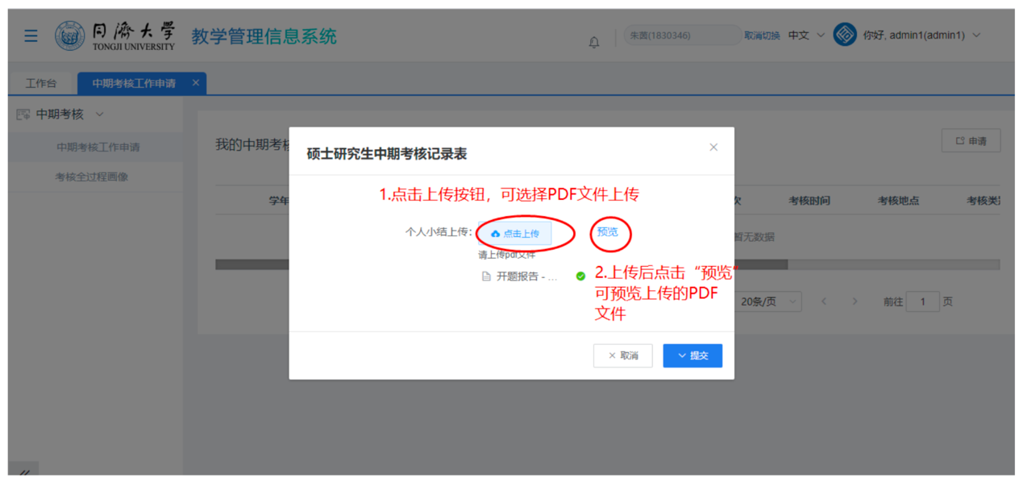

Note: You can upload only one document in PDF form.

**Step 5:** After uploading the PDF document, click “Submit” (提交). Document having been submitted, the process turns to the supervisor assessment stage, where you can trace the progress of assessment.

图形用户界面

**Step 6:** If there is error information, you can click “Withdraw” (撤回) before your supervisors finish the assessment. Later, you can submit the application again.

**2.1.2 Application for Postponement**

**Step 1:** Log in Teaching Information System, entering “Mid-Term Examination”(中期考核) > “Application for Mid-Term Examination”(中期考核工作申请)

**Step 2:** Click “Apply” (申请) to enter the application page, choose “Application for Postponement” (缓考核)

**Step 3:** Click “OK” (确定) to enter the basic information page.

**Step 4:** Choose your reason for postponement, put down your illustration on the reason, upload attachment if necessary, then click “OK” (确定) to submit your application for postponement. After submission you can see the record of applications of postponement.

**Step 5:** Clicking “Check” (查看), you can check detailed information of your application of postponement.

**Step 6:** Clicking “Withdraw” (撤回), you can withdraw your application of postponement, and submit your application again after modification.

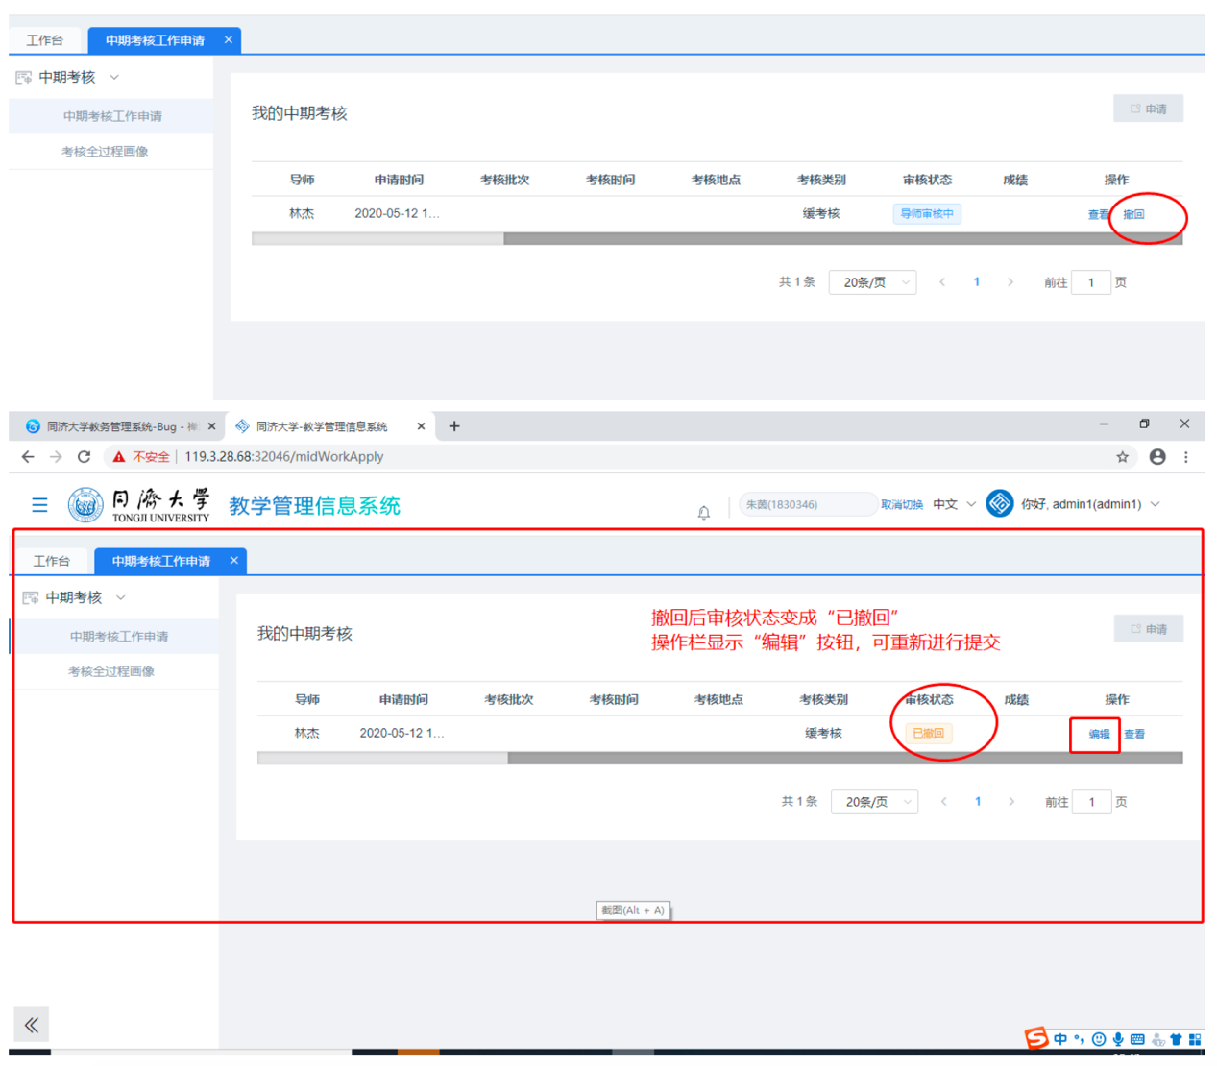

**2.1.3 Withdraw Your Application (Normal Application or Postponement)**

**Step 1:** You can withdraw your applications before the assessment is finished.

**Step 2:** Having withdrawn the application, it turns to the “Withdrawn” status. You can click “Edit” (编辑) or “Apply” (申请) to submit your application again.

**2.2 Process Record**

**Background**

After the application has been approved, the student has been added to the system, the student can click “Entering Record” (录入画像) to the process record page, and record the process of his/her mid-term examination.

Note:

Students cannot record the process of their mid-term examination, unless they have been added to the system.

**Procedure**

**Step 1:** Log in Teaching Information System, entering “Mid-Term Examination”(中期考核) > “Application for Mid-Term Examination”(中期考核工作申请). Click the button “Process Record” (录入画像).

**Step 2:** Entering the process record page.

**Step 3:** Click “Submit”(提交) after filling in the information. Having finished the record, you can turn back to the application page and check the record by clicking the “Check”(查看) button.

**2.3 Query Result**

**Background**

Once the grades have been released, students can enter “Application for Mid-Term Examination”(中期考核工作申请) page to inquire their grades. For students who have applied for postponement of mid-term examination, they can check whether their applications have been approved.

**Procedure**

**Step 1:** Log in Teaching Information System, entering “Mid-Term Examination”(中期考核) > “Application for Mid-Term Examination”(中期考核工作申请). You can see the scores of your mid-term examination.

