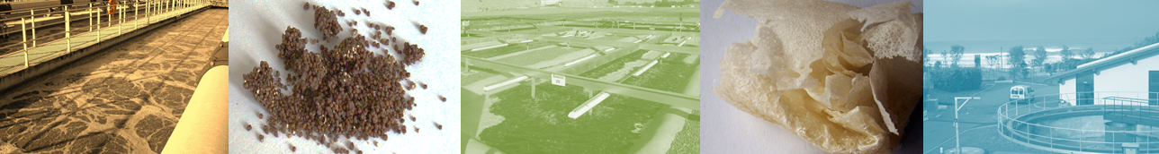

Sino-French Scientific Week
September 25-29, 2012

Water: A Source of Material and Energy

_______
ANR CreativeERU Meeting in Beijing
Sept 25 – 26
Limited to CreativeERU’s participants

_______
Sino-French Scientific Seminar in Shanghai
Sept 27 – 29

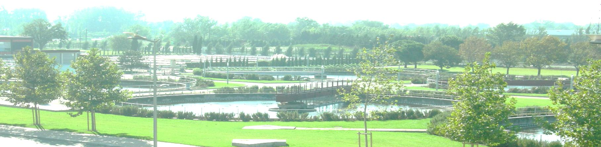

Agenda of “Water: A Source of Material and Energy”
Sept 27 :
Time | Presentation | Speaker
09:00~09:20 | The Review of Sino-French cooperation | Michel Roustan, Pr. Emeritus, LIU Suiqing, Pr.
09:20~09:40 | Biogas, Methane, Biohydrogen. | Jerome Hamelin, Dr., LBE, INRA Narbonne
09:40~10:00 | The CreativeERU Program for Minimizing Environmental Impact of WWTP | Alain Grasmick, Pr, Univ II Montpellier
10:00~10:20 | Sludge Conversion to Polymers (PHA) and Phosphorus Recovery | Mathieu Spérandio, Pr., LISBP-INSA Toulouse
10:20~10:50 | Coffee Break
10:50~11:10 | Separation of Supernatant from Biomass Digestion | Marc Héran, Dr., Univ II Montpellier
11:10~11:30 | Ozone and Desinfection | Michel Roustan, Pr. Emeritus, INSA-Toulouse
11:30~11:50 | Tertiary Treatment for Micropollutants Removal | Christophe Dagot, Pr., Univ. Limoges
11:50~12:10 | Energy and nutrients recovery from animal production andagro-food industry wastewater | Marie Line Daumer, Dr. IRSTEA Rennes

12:10~13:30 | Lunch Break (Sandwich)
13:30~13:50 | Industrial Wastewater Treatment | LI Fengting, Vice Dean
13:50~14:10 | Organic Matter Recovery from Municipal Wastewater | WANG Zhiwei, Associate Professor
14:10~14:30 | Biohydrogen, Methane, and Biochemicals Production from Ananerobic Digestion of Distillery Wastewater | XIE Li, Associate Professor
14:30~15:00 | Coffee Break
15:00~15:20 | Biopolymers Used as Bioflocculant or Biosorbent from Waste Activated Sludge | ZHANG Zhiqiang, Lecturer
15:20~15:40 | Current Situation of Livestock Wastewater Treatment in Henan Province | WAN Junfeng, Associate Professor
15:40~16:00 | Microcystis aeruginosa inactivation using UV-C: Impairment on photosynthetical system and degradation on fluorescence dissolved organic matter | GAO Naiyun, Pr.
16:00~17:30 | Break
17:30 | Dinner (San Hao Wu Restaurant)
Agenda of Discussion
Sept 28 :
Time | Issue
09:30~12:00 | Brainstorming on future Sino-French projects
12:00:13:30 | Lunch (Sandwich)
13:30~16:30 | Discussion concerning future collaborative projects which could be supported by different organisms: MOST, ANR, French Embassy...
17:00 | Dinner or Mid-Autumn Festival Party with IESD

Participants(6 French/ 10 Chinese):

Jerome Hamelin, Dr., LBE, INRA Narbonne
Alain Grasmick, Pr, Univ II Montpellier
Mathieu Spérandio, Pr., LISBP-INSA Toulouse
Marc Héran, Dr., Univ II Montpellier:
Michel Roustan, Pr. Emeritus, INSA-Toulouse
Christophe Dagot, Pr., Univ. Limoges
Marie Line Daumer, Pr., IRSTEA-Renne

DAI Xiaohu, Pr.,Dean, College of Environmental Science and Engineering, Univ Tongji
LI Fengting, Vice Dean, IESD, Univ Tongji
LIU Suiqing, Pr., Univ Tongji
ZHOU Qi, Pr., Univ Tongji
GAO Naiyun, Pr., Univ Tongji
SUI Minghao, Associate Professor, Univ Tongji
WANG Zhiwei, Associate Professor, Univ Tongji
XU Ran, Associate Professor, Univ Tongji
XIE Li, Associate Professor, Univ Tongji
ZHANG Zhiqiang, Lecturer, Univ Tongji
WAN Junfeng, Associate Professor, School of Chemical Engineering and Energy, Univ. Zhengzhou

Technical Visits for French Participants
Sept 29 :
Time
08:30 | Set out from the Days hotel
09:30-11:30 | Visit Bailonggang sewage treatment plant  To meet the burgeoning demand on sewage treatment, in 1999 the 680-million-yuan($107 million) Bailonggang sewage treatment plant was opened in Pudong New Area andlater was extended as one way of attacking the problem of dealing with thepollution that resulted from the huge amount of sewage. Equipped with advanced sewage treatment technology, such as AAO multi-mode treatment process and intensive arrangement, the Bailonggang Sewage Treatment Plant is the largest of its kind in Asia.

Contact:
Maggie SHEN
UNEP-Tongji Institute of Environment for Sustainable Development, Tongji University
Room 903, Zonghe Building, 1239 Siping Road, Shanghai, 200092, P.R.China
Office: +86-21-6598 7790/5059 Mobile: +86-13816542292
Email: shenjiaqi@tongji.edu.cn

